# CS 255 System Design Document

Rob Marlatt

## UML Diagrams

### UML Use Case Diagram

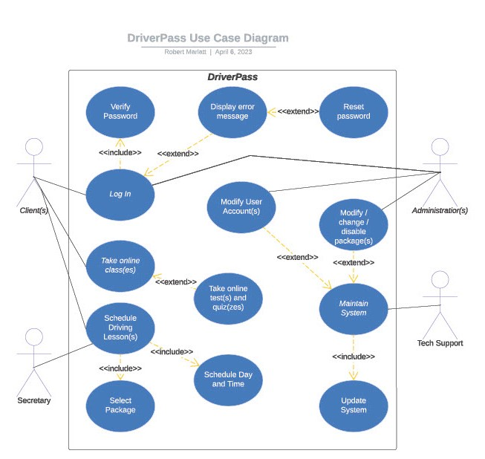

### UML Activity Diagrams

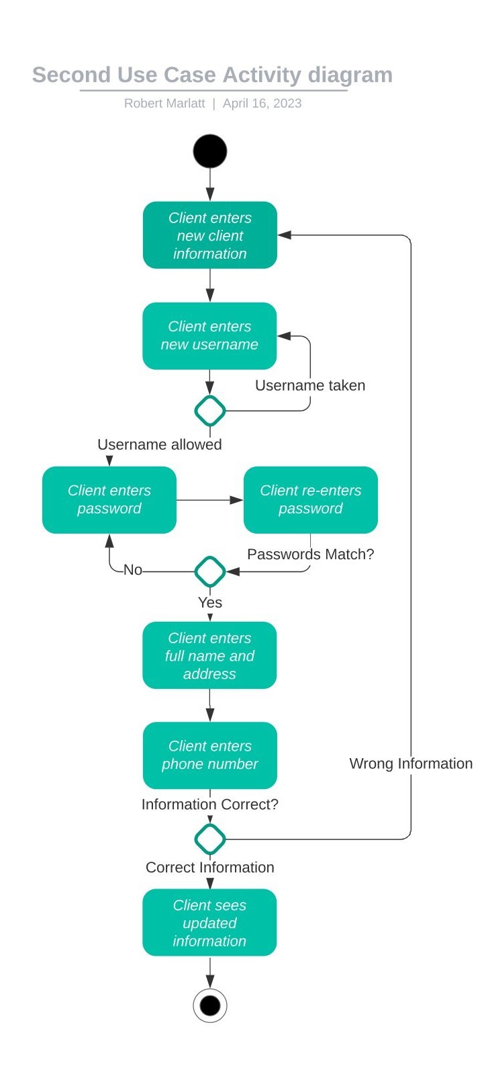

### UML Sequence Diagram

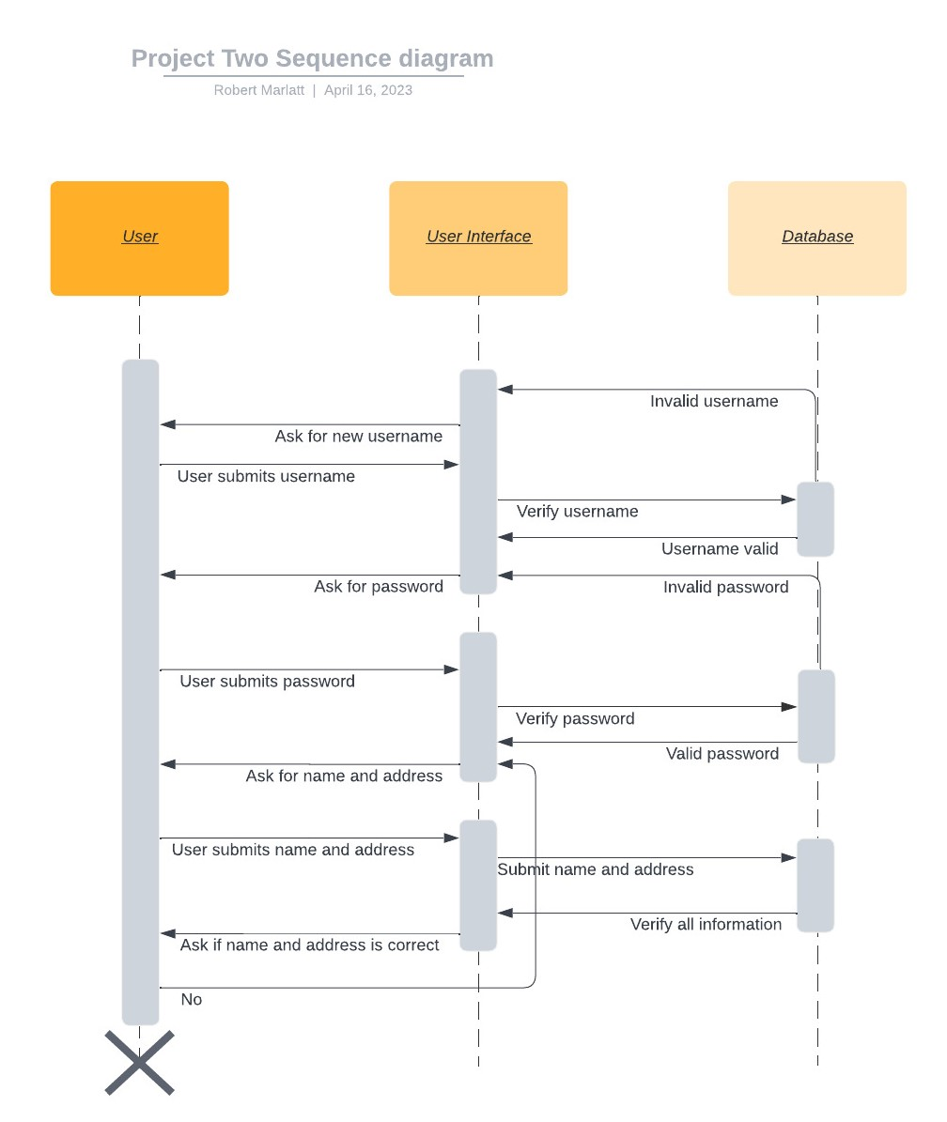

### UML Class Diagram

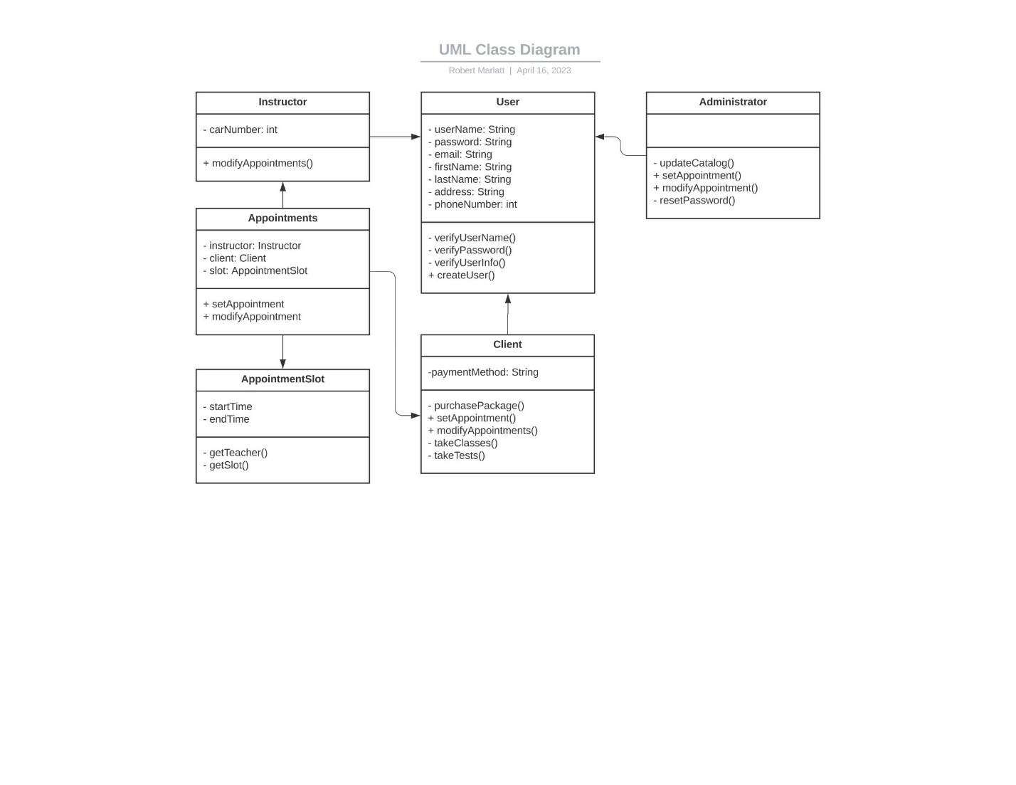

## Technical Requirements

* Payment Processing
* Network Interface
* Testing
* Maintenance